 | Family Connections Calendar
∙ Sunday ∙ | ∙ Monday ∙ | ∙ Tuesday ∙ | ∙ Wednesday ∙ | ∙ Thursday ∙ | ∙ Friday ∙ | ∙ Saturday ∙
April 2022 |  |  |  |  | 1 | 2  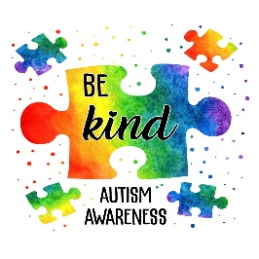
3  Science Sunday  Did you know soaking an egg in a cup of vinegar for 12-24 hours can dissolve the shell of the egg? Try it out! | 4  Mindful Monday  Try a short mediation with the family. Head to YouTube and search Headspace for a guided meditation. They have great options! | 5  Affirmations  Tell your child-  You are confident!  You are a great friend!  You are important! | 6  Cardboard Mural  Use a flattened box and crayons, markers, or paint to create a family masterpiece! | 7  Sensory Play  A large bowl of water and cups or spoons is all you need. Don’t forget a towel! | 8  Read Together  It’s never too early, or late, to begin a routine of reading with your little ones. | 9  Parent Café!  Join us on Zoom from 10-11am. We are sharing tips to benefit our children! E-mail jennalee@ccc-nj.org for Zoom link!
10  Potluck Dinner  Assign dishes and help the little ones in the kitchen with bringing their dish to family dinner. | 11  Music Monday  Empty water bottles filled with rocks, rice, or beans make great instruments. | 12  Exercise!  There are great, family-friendly exercise videos on YouTube to try out. | 13  Email to register:  jennalee@cccnj.org | 14  Act it Out  Charades is a great game to get the entire family involved. | 15  Pizza Party Day! | 16  Bunny Chase Spring Celebration!  Family fun event at Terhune Orchards from 10am- 4pm. Admission is $10, located at 330 Cold Soil Road, Princeton, NJ.
17 | 18  Mindful Monday  Download the free app named, Stop, Breathe, & Thinks Kids and try the ‘mindful missions.’ | 19  Affirmations  Tell your child-  You are a great child!  You are beautiful!  You are capable! | 20  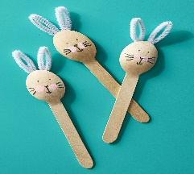  Bunny Spoons | 21  Sensory Play  A large bowl of water and cups or spoons is all you need. Don’t forget a towel! | 22 | 23  Mini Growers  Children 3 and up are invited to create their own mini greenhouses from 10:30-11:30am. Call 609-799-0462 to register.
24  Science Sunday  Use a large bowl of water and various objects from around the house to see if they will sink or float. | 25  Music Monday  Empty water bottles filled with rocks, rice, or beans make great instruments. | 26  Exercise!  There are great, family-friendly exercise videos on YouTube to try out. | 27  Cardboard Mural  Use a flattened box and crayons, markers, or paint to create a family masterpiece! | 28  Act it Out  Charades is a great game to get the entire family involved. | 29  Read Together  It’s never too early, or late, to begin a routine of reading with your little ones. | 30  Karaoke Night  No microphone? No problem! Pretend you’re on stage using a remote control, and sing your heart out!

